Built-in ORM (Object Relational Mapper)
is a feature provided by frameworks like Django that allows developers to interact with a database using Python objects instead of writing raw SQL queries. It maps database tables to classes and records to objects, making database operations simpler, more secure, and more readable.
Example (for clarity):
Instead of writing SQL:
SELECT * FROM users;
You write:
User.objects.all()
Key points you can mention in interview:
- No need to write SQL manually
- Improves code readability
- Prevents SQL injection (more secure 🔒)
- Faster development
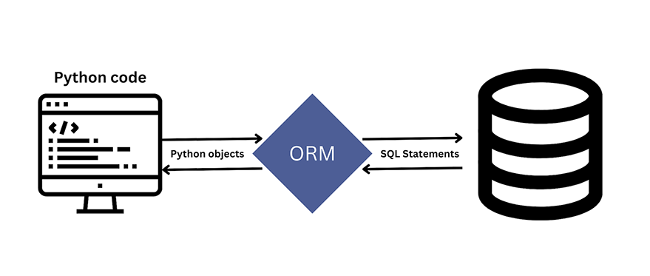

⚠️ How ORM prevents SQL Injection
First, recall SQL Injection:
It happens when user input is directly injected into SQL queries.

❌ Without ORM (Vulnerable)
query = "SELECT * FROM users WHERE username = '" + username + "'"
User input:
' OR '1'='1
👉 Query becomes dangerous → returns all data 🚨

✅ With Django ORM (Safe)
User.objects.filter(username=username)
👉 What Django does internally:
- Uses parameterized queries
- Escapes special characters
- Treats input as data, not code

🔐 How exactly ORM protects
- Uses prepared statements (parameters)
- Automatically sanitizes input
- Separates query structure from user data
👉 So even if user enters:
' OR '1'='1
It will be treated as a string value, not SQL logic ✅

Django ORM prevents SQL Injection by using parameterized queries and separating user input from SQL logic, ensuring that inputs are treated strictly as data.

